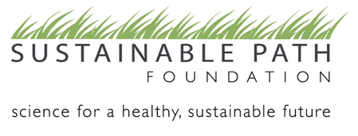

2012 Letter of Inquiry

Cover Sheet

ORGANIZATION NAME:

What is your organization’s EIN/Tax ID number?

What is your organization’s total budget for 2011?

What is your organization’s total budget for 2012?

What are the start and end dates of your fiscal year?

PROJECT NAME:

Does this project have a website? If so, please provide it.

Is this a new or an ongoing project for your organization?

Amount of the request?

Name of chief executive:

Name and title of contact person for this application:

E-mail address:

Telephone:

Street address:

Fax number:

Narrative
Eligible organizations with proposed projects that align with Sustainable Path Foundation’s Request for Proposals (RFP) should provide a Letter of Inquiry no longer than two pages in length (exclusive of the Cover Sheet and Attachment) containing all of the following information.
Please provide:
- A description of the issue(s) the project will address. What are the needs and opportunities?
- A description of the activities, outputs, and outcomes of your project.
  - Activities are what you will do.
  - Outputs are quantitative results of activities.
  - Outcomes are specific changes in behavior, knowledge, skills, status, and level of functioning – what you hope will happen. Examples are voters passing a referendum or reduced levels of pollution in estuaries. Short-term outcomes may take one to three years to achieve and long-term outcomes may take four to six years or longer.
- A description of how your project addresses (a) Sustainable Path’s focus on science and systems thinking and (b) any or all of the focus areas defined in the RFP.
- Briefly indicate how the successful project can lead to an anticipated long-term or sustained impact on our region.
- A list of other organizations doing the kind of work you propose (in the Puget Sound region) and a discussion of how your proposed project fits in.

Attachment
Please include verification of your organization’s 501(c)(3) status.

Format and Submission Instructions
Please use 12-point font, 1” margins, and single spacing for your narrative. Any material submitted that exceeds the two-page narrative limit and the one requested attachment will not be reviewed. Please prepare and send your Cover Sheet, letter of inquiry, and attachment as both Word and PDF files. If your organization does not have PDF software, Sustainable Path Foundation staff is available to help with the conversion.

We are interested in learning about your work and strongly encourage you to call and discuss your proposal idea. Please contact Erika Orsulak, Sustainable Path Foundation Managing Director, at (206) 443-8464 or via email at erika@sustainablepath.org.

Please submit all required documents via e-mail to erika@sustainablepath.org by Monday, January 9, 2012.

